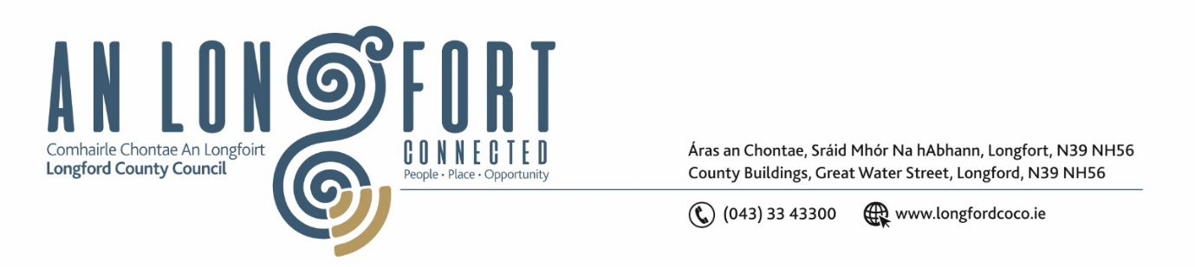

***LONGFORD MUNICIPAL DISTRICT***

***Please note meeting will be held in Council Chamber***

**16th July 2021.**

**To: Each Member of Longford Municipal District.**

**Dear Member,**

You are requested to attend the Meeting of Longford Municipal District to be held

**in Council Chamber, Aras an Chontae** on **Wednesday 28th July 2021 at 3.30pm** to transact business, as set out on the Agenda hereunder.

**Yours sincerely**,

Ann Marie Mc Keon

_______________

**Ann Marie Mc Keon**

**Meetings Administrator.**

**AGENDA**

Prayer before meeting.

**1.** Confirmation of Minutes of meetings held on:

**(i)** Longford Municipal District Meeting held on Wednesday 23rd June 2021 – copy

enclosed.

**(ii)** Longford Municipal District Annual Meeting held on Wednesday 23rd June 2021

– copy enclosed.

**2.** Matters arising from Minutes.

**3.** Declaration of Interest by Members.

**4**. Risk Assessment - Attendance at Council Meetings by Elected Members & Council

Officials and attendance at other meetings or council buildings – enclosed.

**5.** Management Report - to follow.

**6**. Update on: Lease Michael Nearney Park

Taking in charge of Leader Park

Abbeycarton/Battery Road Scheme

Footpath at Melview

Caravan at Richmond Street

Update on traffic lights at main street

Safety Audit/Children at Play Signs

**7**. Proposed Projects/Expression of interests - enclosed.

**8. Notices of Motions, submitted by Councillors, as listed hereunder –**

**Councillor Uruemu Adejinmi**

(i) There are no public bins by the harbour and along the Canal walkways in Clondra and I am calling on Longford County Council to have been bins placed in these locations to keep the areas litter free.

(ii) The L50953 road needs resurfacing and there is poor visibility at the junction approaching the Regional Road. The trees and overgrown hedges at the junction make it difficult for residents in the area to exit onto the regional road safely. I am calling on Longford County Council to carry out a low-cost safety scheme at the L50953 junction as well as road resurfacing on the L50953 to help improve visibility and driving condition for save movement of residents on the road and at the junction.”

(iii) I call on the staff of Longford County Council to, going forward, prepare a record of Motions submitted to Longford Municipal District, for an update on status of same to be made to Councillors on a yearly basis as well as a quarterly informal meeting with the Cathaoirleach and Administration officer. This will help us keep track of motions until they are completed, allow Councillors provide real time status updates to constituents and prevent duplication of motions.

**Councillor John Browne**

I call on Irish Water and Longford County Council between them, to take full responsibility, and rectify without any further delay the sewage problems (obnoxious smell, manholes, gullies on the roadway full of sewage) at the Cartron Breac Housing Estate. The estate was formally taken in charge at the November 2018 Municipal Meeting. However Irish Water claim to have a Taking in Charge Application as of April 2021. It’s summertime, heat, children at play, charge or no charge, the estate residents require immediate action.

**Councillor Martin Monaghan**

That the Longford Municipal District liaise with An Garda Siochana and or community sergeant to control the scourge of electric scooters that are appearing on our streets, with a lot of young children on same at present.

**Councillor Seamus Butler**

‘That Longford Municipal District will introduce a By Law to prohibit the riding of bicycles, tricycles, quad bikes, motor bikes and scooters, motorised or self- propelled, on all footpaths in the Longford Municipal District. This will apply to all persons over 12 years of age and breaches will be subject to an appropriate fine. Wheelchairs and motorised transport for registered disabled persons are excluded.’